Your Monday Morning Priority — Ministers Conference — 10:30–11:30 a.m.
“And Moses said to Aaron, ‘This is what the LORD spoke, saying:’ ‘By those who come near Me I must be regarded as holy; and before all the people I must be glorified.’”
－Leviticus 10:3 (NKJV)

____________
MBA Website
Find us on Facebook!
(256) 773-5243

MBA News and Notes Volume 4, Issue 32, August 21, 2019

  - 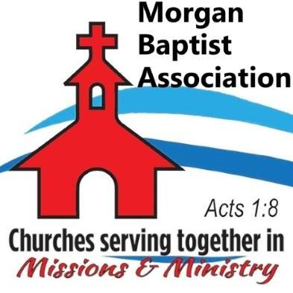

  - Volume 1 | Issue 43
October 26, 2016
Aug 26 — Jamin Grubbs — Pastor, Trinity Baptist Church
Sep 2 — No Meeting — Labor Day
Sep 9 — Randy Berry — Pastor, Austinville Baptist Church
Sep 16 — Nolan Stinnett — Former Director of Missions
Sep 23 — Scott Walters — Member, West Hartselle Baptist Church
Sep 30 — Jon Burdett — Evangelist, "Every Believer a Witness"
Oct 7 — Ron Puckett — Morgan County Sheriff
Oct 14 — Rick Freeman — Pastor, Woodville Baptist Church
Oct 21 — Alan Queen — Pastor, Bellview Baptist Church
Oct 28 — No Meeting — MBA Annual Meeting that evening
Nov 4 — Tom Campbell — Pastor, Shady Grove Baptist Church
Attention All MBA Churches: Your Annual Church Profile packet is at the MBA office available for pickup Mon. —Thu., 8:00 am - 4:00 pm. If it will be difficult for someone from your church to pick up your packet, call Belinda at (256) 773-5243 and she will mail it to you.
Ministry Training Institute (MTI) — August 27, 6:00-9:00 pm — Hacker Hall. Pastor Wally Blackman will continue an eight-week “Study of the Minor Prophets” as part of the MTI curriculum offered in partnership with Samford University.
Mission Mexico — August 30-September 6. Volunteer Missionaries from Morgan Association will work with IMB Missionaries Charles and Robin J. near Aguas Calientes, Mexico.
MBA Trustee Meeting — September 3, 9:00 am — MBA Conference Room.
MBA Disaster Relief Team Meeting — September 3, 10:00 am — Hacker Hall.
Caring Place Bible Study — September 5, 11:00 am — Liberty Baptist Church – Pray for Pastor Wally Blackman as he teaches Caring Place Clients from the Book of Revelation.
MBA Senior Adult Luncheon — September 5, 12:00 noon — MBA Hacker Hall. Come enjoy fellowship and a meal together with brothers and sisters from around our association.
MBA Leadership Team Meeting — September 9, 9:00 am — MBA Conference Room.
Sav-A-Life Pastor Appreciation Dinner September 12, 6:30 pm — West Hartselle Baptist Church. Leaders of Youth, Children or Senior Adult Pastors and spouses are invited to enjoy an evening of appreciation! This free event will include door prizes! RSVP and see full information at Sav-A-Life Pastor Appreciation Dinner.
Morgan Baptist Association 100th Annual Meeting — October 28, 2019 — Hartselle First Baptist Church. Mark your calendar and plan to attend this special celebration of 100 years of ministry through your association!
PRAY for these MBA Churches seeking pastors: Cave Spring, Cedar Ridge, Flint, Mt. View, Oak Forest, Parkview, Rock Creek, Shoal Creek.

