Your Monday Morning Priority — Ministers Conference — 10:30–11:30 a.m.
Feb 17 — Greg Lee — Pastor, West Hartselle Baptist Church
Feb 24 — Trace Donahoo — Gospel Opportunity Ministries
Mar 2 — Mahlon LeCroix — Pastor, Shoal Creek Baptist Church
Mar 9 — Jimmy Legg — Pastor Oak Ridge Baptist Church
Mar 16 — Dr. Mark Tew — President, Judson College
Mar 23 — Dennis Trimble — Director of Missions, West Cullman Baptist
Association
Mar 30 — Christopher Campbell — Pastor, Southside Baptist Church
April 6 — Chris Martin — Pastor, Pleasant Hill Baptist Church
April 13 — Rob Hatfield — Pastor, Central Baptist Church
April 20 — George Yates — Alabama State Board of Missions, Church Health
Strategist
April 27 — Robert (Bunky) Smith — Director of Missions, Muscle Shoals Baptist
Association
Jesus answered and said to her, “If you knew the gift of God, and who it is who says to you, ‘Give Me a drink,’ you would have asked Him, and He would have given you living water.”
John 4:10 (NKJV)
____________
MBA Website
Find us on Facebook!
(256) 773-5243

MBA News and Notes Volume 5, Issue 6, February 12, 2020

  - 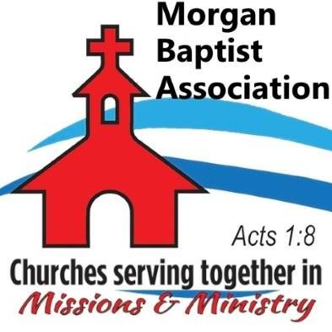

  - Volume 1 | Issue 43
October 26, 2016
VBS Clinic — February 17, 8:30 am-12:00 pm — Westmeade Baptist Church. The Morgan Baptist Association VBS Team will join other associational VBS Teams to review this year’s VBS theme, materials, and plans.
Ministry Training Institute (MTI) — February 18, 6:00-9:00 pm — Hacker Hall. Dr. Matt Haines continues an eight-week study of Biblical Foundations II as part of the Ministry Training Institute curriculum offered in partnership with Samford University.
Pastor Enrichment Network (P.E.N.) Meeting — February 18, 6:30-8:30 pm. — MBA Office. Bivocational Ministers and Wives will meet for a time of fellowship, encouragement, and mutual edification.
Caring Place Bible Study — February 20, 11:00 am — Liberty Baptist Church — Pray for Pastor Wally Blackman he teaches the Word of God to Caring Place Clients.
MBA Finance Committee Meeting — February 20, 6:30 pm — MBA Conference Room.
2020 State Evangelism Conference — February 23-24 — Heritage Baptist Church, Montgomery. Speaker include: Don Wilton, Michael Catt, Brett Kunkle, Robert Smith, Vance Pitman, and Sean McDowell.
VBS Director and Pastors Preview — February 24, 6:30 – 8:00 pm — Hacker Hall. Pastors and VBS Directors come to the Morgan Baptist Association for a preview of the 2020 Vacation Bible School curriculum and plan.
MBA Senior Adult Luncheon — March 5, 12 Noon — Hacker Hall. Join MBA Senior Adult Team Leader Ozella Stewart and senior adults from around our association as they gather for a meal and fellowship.
A Night with Tony Evans — March 5, 6:45 pm — Lindsay Lane Baptist Church, 1300 Lindsay Lane S, Athens, AL. $10 per person. Tickets at lindsaylane.org.
PRAY for these MBA Churches seeking pastors: Cave Spring, Cedar Ridge, Flint, Mt. View, New Friendship, Oak Forest, Sixteenth Avenue.

