Ministers Prayer Meeting — Monday — 10:15–11:30 a.m.
Feb. 21 — Pastors/Ministers meet for fellowship and prayer.
Feb. 28 — Pastors/Ministers meet for fellowship and prayer.
MBA Finance Committee Meeting — February 17, 6:30 pm — MBA Conference Room.
“What you have heard from me in the presence of many witnesses, commit to faithful men who will be able to teach others also.”
2 Timothy 2:2 (CSB)
______________
http://morganassociation
.weebly.com/

https://www.facebook.com/morgancountyalabama/
(256) 773-5243
______________

MBA News and Notes Volume 7, Issue 6, February 16, 2022

  - 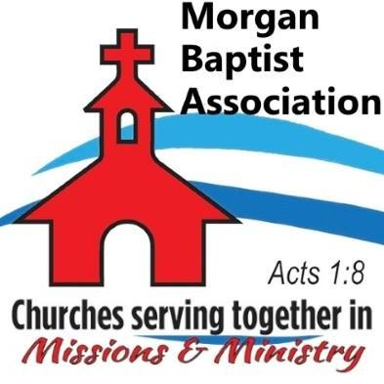

  - Volume 1 | Issue 43
October 26, 2016
Pastors’ Golf Outing — February 18, 8:00 am — Sunset Landing Golf Course. 346 James Record Rd SW, Huntsville, AL. Leave from MBA at 8:00 am.
MBA Disaster Relief Deployment — February 20-27 — Five MBA DR volunteers will join others to aid in ash removal and cleanup in the aftermath of wildfires in Colorado. Pray for safety and ministry opportunities as our DR Team goes out.
MBA National Day of Prayer Planning Meeting — February 21, 9:00 am. — Planning for upcoming NDP Observance. Mark your calendar on May 5 now!
VBS Live 2022! — Training for associational VBS teams and church VBS leaders. — February 21, 5:15 - 8:30 pm — Lindsay Lane Baptist Church, Athens.
BCM (Baptist Campus Ministries) Bible Study — Calhoun Community College Campus ⎯ February 22, 12:00 Noon ⎯ Campus Bible study for students at CCC. Instructor: Will Faulkenberry.
Ministry Training Institute (MTI) — February 22, 6:00-9:00 pm. MTI will continue a study of the Parables of Jesus. Instructor: Matt Haines.
2022 Associational Missionary Personal Development Workshop ⎯ February 24-25 ⎯ Shocco Springs. Pray for DOMs from around our state as they meet for training and to encourage one another in the ministry.
MBA Trustee Meeting — March 1, 9:00 am — Pray for our trustees as they meet to discuss plans for the maintenance and care of all of the MBA facilities.
MBA Disaster Relief Team Meeting — March 1, 10:00 am — Hacker Hall.
Sharing Hope Conference — March 13, 5:30 pm. evening service and March 14, 11:30 am. An annual statewide event for encouraging and equipping pastors and churches in the work of evangelism. — First Baptist Church, Cullman.
PRAY for these MBA churches seeking pastors: Bell Springs, Chapel, Fellowship, Gum Springs, New Friendship, Mt. Zion.

